WS A3-2: ENTITY
TOPIC
A3
RELATIONSHIP DIAGRAMS

TIME TO COMPLETE: 0.5 HOURS

MAX MARKS: 22
- Environmental Systems and Societies (ESS) students are collecting data about the plant species found of sand dunes as part of their internal assessment. The data is collected from 10 sites using the following paper form.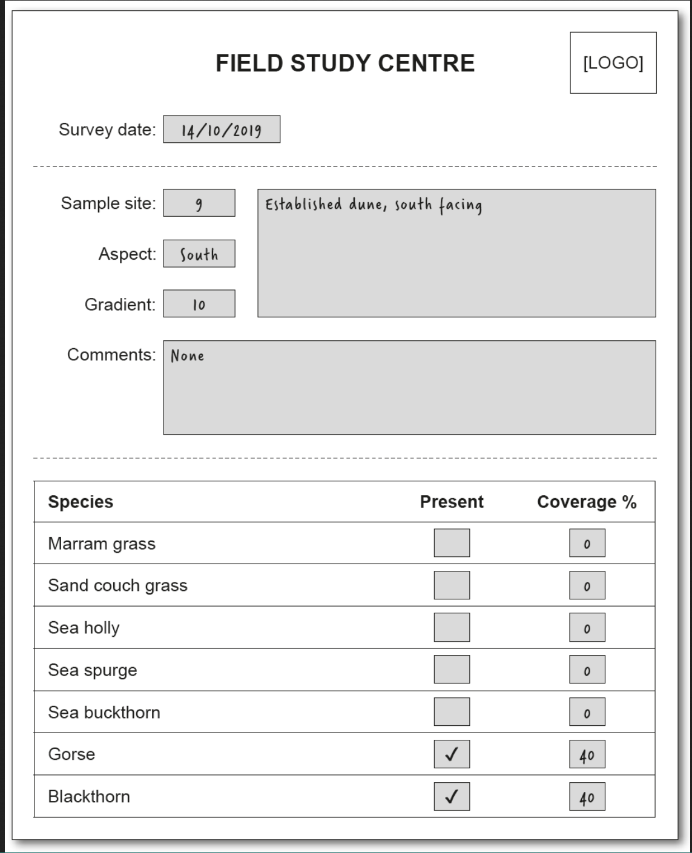

  - State the data type for
    - Species [1]

    - Gradient [1]

Below are three of the entities in the Environment database:
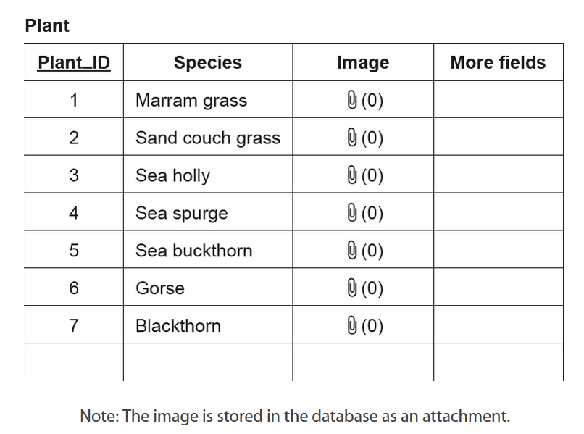
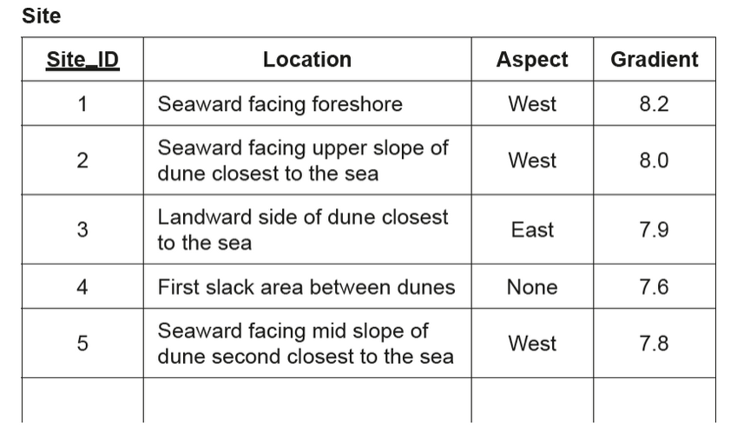
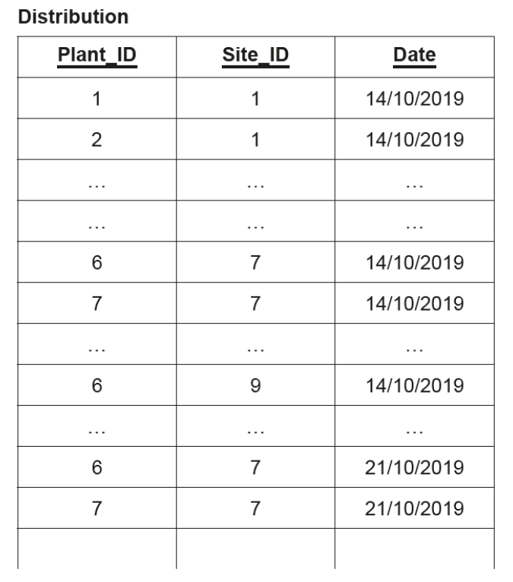

  - Construct an Entity Relationship Diagram (ERD) for the Plant, Site, and Distribution tables. Include cardinality, modality, and the data types for each attribute. I would recommend drawing this on paper and taking a picture of it. [10]

  - Outline why a composite primary key is used for the Distribution table. [2]

- Explain the difference between a conceptual schema and a logical schema [2]

- Identify two characteristics of a conceptual schema. [2]

- A derived field in a database is an attribute that is calculated on the fly based on other data already available, rather than stored permanently in the database.
  - Outline one reason why a derived field would be used in a database. [2]

  - Describe how a derived field of Age would be calculated. [2]

